30.78: a) Using Kirchoff’s Rules on the left and right branches:
Left: 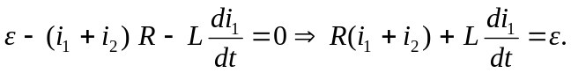
Right: 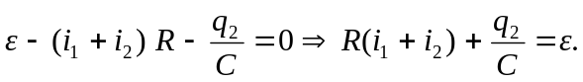
b) Initially, with the switch just closed, 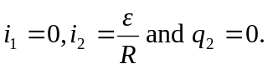
c) The substitution of the solutions into the circuit equations to show that they satisfy the equations is a somewhat tedious exercise in bookkeeping that is left to the reader.
We will show that the initial conditions are satisfied:
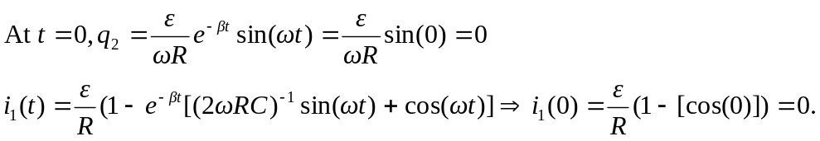
d) When does first equal zero? 